A REPORT ON
Automated Rubric-Based Evaluation of IELTS Essays Using Transformer-Based Sentence Classification
Submitted to
DEPARTMENT OF COMPUTER SCIENCE

of
COLLEGE OF SCIENCE AND MATHEMATICS

CALIFORNIA STATE UNIVERSITY, FRESNO

Submitted by
Ritvik Mahapatra (ID: 301894867)
Rajesh Chirivella (ID: 301922375)

Under the guidance of
David Ruby

ACADEMIC YEAR 2025
SEMESTER Spring 2025

Abstract

Evaluating IELTS essays manually is time-consuming, subjective, and often inconsistent across evaluators. This project proposes an automated system for rubric-based evaluation of IELTS essays using transformer-based sentence classification models. By leveraging the contextual understanding capabilities of transformer architectures like BERT and its variants, the system classifies individual sentences based on specific IELTS rubric criteria, such as Task Achievement, Coherence and Cohesion, Lexical Resource, and Grammatical Range and Accuracy. The sentence-level classifications are aggregated to generate an overall band score prediction for the essay, providing detailed feedback aligned with IELTS standards. The approach aims to improve evaluation consistency, reduce grading time, and offer insightful feedback to learners. Extensive experiments are conducted to fine-tune transformer models, address rubric overlaps, and evaluate system performance against human-graded essays. The project demonstrates that transformer-based sentence classification can serve as an effective and scalable solution for automated IELTS essay evaluation.

CONTENTS
- INTRODUCTION
- DATASET OVERVIEW & DATASET DESIGN
2.1 IELTS Essay Dataset
- DATA EXPLORATION AND INSIGHTS
3.1 Data Preprocessing
3.2 Dataset Splitting

3.3 Sentence Segmentation

3.4 Rubric Label Assignment

3.5 Text Normalization

3.6 Tokenization and Input Formatting

4. ARCHITECTURAL DESIGN PROPOSED APPROACH

4.1 Overview of the Architecture

4.2 Stage 1: First Transformer – Embedding Generation

4.3 Stage 2: Second Transformer – Sentence Classification

4.4 Stage 3: Simple Classifier – Confidence Validation

4.5Postprocessing

4.6 Summary of Architecture Flow

5.FINAL RESULT

6. CONCLUSION

7. FUTURE WORK

PROBLEM STATEMENT:

Evaluating IELTS writing tasks is a complex, time-consuming, and often subjective process that requires significant human effort. In the current system, human examiners assess essays based on four main rubrics: Task Response, Coherence and Cohesion, Lexical Resource, and Grammatical Range and Accuracy. However, manual evaluation faces several challenges — inconsistencies between graders, biases, fatigue, and scalability issues when dealing with large volumes of essays.

This research aims to automate part of the evaluation process by focusing on sentence-level classification of essay content based on rubric-specific criteria, specifically Task Response, Coherence and Cohesion, and Lexical Resource, while excluding Grammatical Range and Accuracy due to its highly syntactic nature that demands specialized grammar analysis. The goal is to develop a transformer-based system capable of analyzing each sentence in an essay and categorizing it according to the most relevant rubric dimension.

Automating this classification process serves multiple purposes:
- Assisting human graders by highlighting relevant portions of text according to rubric categories.
- Reducing evaluation time by providing a structured overview of essay strengths and weaknesses.
- Enhancing grading consistency by minimizing human subjectivity and grader variability.
By leveraging the deep contextual understanding of transformer models, this project seeks to bring higher accuracy, fairness, and scalability to the IELTS essay evaluation process, ultimately making assessments more reliable and efficient.

1. INTRODUCTION

The International English Language Testing System (IELTS) is one of the most widely recognized English proficiency exams globally. Among its four modules, the Writing Task is particularly challenging to evaluate due to the subjective nature of essay grading. Human evaluators assess essays based on four critical rubrics: Task Response, Coherence and Cohesion, Lexical Resource, and Grammatical Range and Accuracy. However, manual assessment is time-intensive, prone to inconsistencies, and subject to human biases, especially when handling large numbers of essays.
With advancements in Natural Language Processing (NLP), there is a growing opportunity to automate aspects of essay evaluation to support human graders and improve the overall reliability and efficiency of the assessment process. Transformer-based models, such as BERT and its derivatives, have shown remarkable success in understanding the contextual and semantic structure of text, making them well-suited for tasks like rubric-based sentence classification.
This project proposes the development of an automated rubric-based evaluation system that classifies individual sentences of IELTS essays into three rubric categories — Task Response, Coherence and Cohesion, and Lexical Resource — using transformer-based sentence classification models. The system aims to highlight the relevant contributions of different parts of an essay towards the final score, thereby assisting human evaluators, reducing evaluation time, and promoting consistency across assessments.
By combining the power of deep learning with the needs of educational assessment, this research seeks to bridge the gap between automated evaluation and human judgment, offering a practical solution for scalable, fair, and efficient IELTS essay scoring.

2. Dataset Overview and Database Design
This project utilizes dataset —IELTS Essay Data — designed for different analytical and modeling purposes. Both datasets have been carefully cleaned, normalized, and structured to enable accurate downstream processing and analysis.

2.1 IELTS Essay Dataset (for Transformer Modeling)
The second major dataset used focuses on IELTS Writing Task 1 and Task 2 essays, collected from a variety of reputable online educational platforms, IELTS preparation websites, and public resources. These essays reflect a diverse range of student abilities, essay types, and topics, providing a realistic foundation for machine learning model training and evaluation.
Each essay entry includes:
- Title/Question Prompt: The specific IELTS writing task or scenario that the essay addresses.
- Full Essay Text: The complete written response, usually containing multiple structured paragraphs.
To enable rubric-specific sentence classification, essays were:
- Manually or semi-automatically segmented into individual sentences.
- Each sentence was labeled based on the primary IELTS rubric it contributes to:
  - Task Response (TR): Sentences that address the task or answer the prompt.
  - Coherence and Cohesion (CC): Sentences that maintain logical flow and essay structure.
  - Lexical Resource (LR): Sentences showcasing vocabulary range, precision, and topic-specific terms.

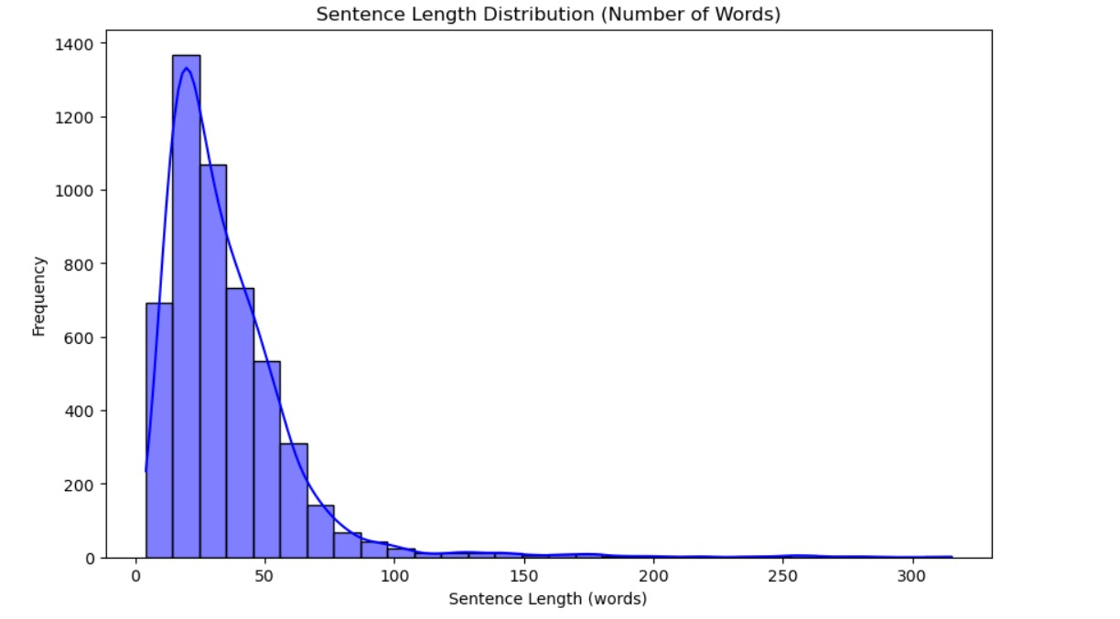
This figure shows the distribution of sentence lengths in the IELTS essay dataset, measured by the number of words per sentence.
• Most sentences are concentrated between 20 to 50 words, indicating the typical length range used by students in academic writing.
• The distribution is right-skewed, with a long tail extending towards sentences exceeding 100 words.
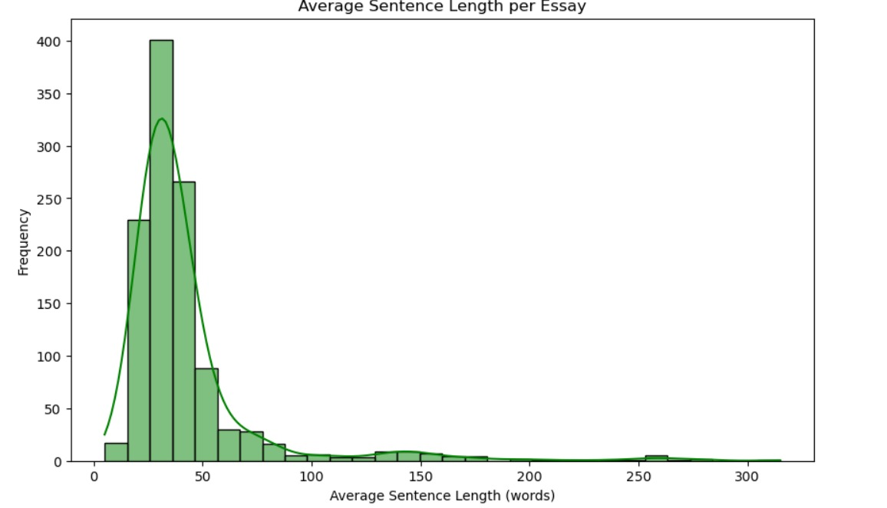
This figure illustrates the distribution of average sentence length (measured in number of words) across essays in the IELTS writing dataset.
• Most essays have an average sentence length between 30 to 50 words.
• The distribution is right-skewed, indicating that while the majority of essays use concise sentence structures, a few essays have longer, more complex sentences that increase the average.
The distribution suggests that clear and concise writing is typical among IELTS candidates, aligning with academic writing best practices.

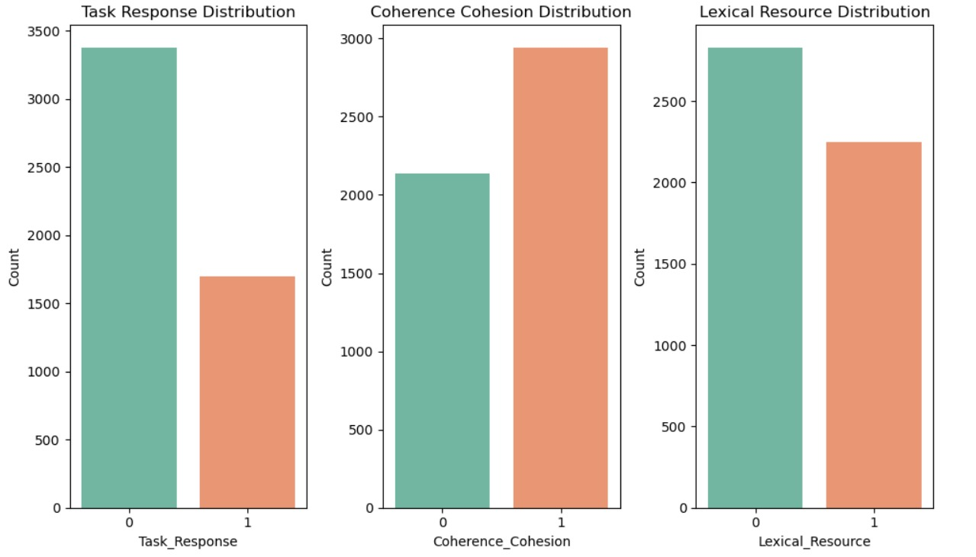
This figure presents the distribution of sentence labels across the three primary IELTS rubrics used for classification: Task Response, Coherence and Cohesion, and Lexical Resource.

3.DATA PREPROCESSING

3.1 Data Preprocessing
To prepare the IELTS essays for transformer-based sentence classification, the following preprocessing pipeline was designed and implemented:

3.2 Dataset Splitting
- The full dataset was first split into Training and Validation sets.
- 80% of essays were used for training, and 20% for validation.
- Splitting was performed stratified by rubric label to maintain balanced representation across Task Response, Coherence and Cohesion, and Lexical Resource categories.

3.3 Sentence Segmentation
- Each essay was divided into individual sentences using rule-based sentence tokenizers (NLTK’s sent_tokenize ).
- Special attention was given to:
  - Handling abbreviations (e.g., "e.g.", "i.e.") correctly.
  - Managing missing punctuation and informal writing.
  - Properly segmenting long compound sentences.

3.4 Rubric Label Assignment
- A manual Python script was developed to label sentences into three IELTS rubric categories:
  - Task Response (TR)
  - Coherence and Cohesion (CC)
  - Lexical Resource (LR)
- Sentences were labeled either manually or semi-automatically, then verified by human annotators to ensure label accuracy.
- Sentences without a clear rubric contribution were removed from the dataset to maintain label purity.

3.5 Text Normalization
- Minimal cleaning was applied to preserve authenticity:
  - Lowercasing only where necessary.
  - Whitespace removal to fix formatting.
  - Minor punctuation corrections without changing meaning.
  - Spelling and grammar errors were intentionally preserved to simulate real-world IELTS student writing.

3.6 Tokenization and Input Formatting
- Sentences were tokenized using a simple BERT transformer tokenizer (bert-base-uncased) for the first transformer model training.
- Special tokens ([CLS], [SEP]) were added as required by BERT architecture.
- Sentences were padded or truncated to a maximum sequence length (e.g., 128 tokens) to allow for efficient batch training.

4. Architecture Design and Proposed Approach
To enhance the rubric-based evaluation of IELTS essays, this project proposes a multi-stage architecture involving three interconnected models:

4.1 Overview of the Architecture
The overall system consists of three main modeling stages:
- First Transformer: Trained to generate rich word embeddings from essay tokens.
- Second Transformer: Trained on top of first transformer's embeddings to classify sentences into rubric categories.
- Simple Classifier: Used after the second transformer to verify predictions based on confidence scores.
This modular design separates feature extraction, classification, and confidence checking, improving flexibility, interpretability, and performance.

4.2 Stage 1: First Transformer – Embedding Generation
- Objective:
Train a first transformer model specifically for generating contextualized token-level embeddings from IELTS essay data.
- Training Strategy:
  - The first transformer is trained to perform Masked Language Modeling (MLM) by predicting masked tokens using the surrounding token context.
  - It uses previous tokens as input to better capture essay structure, sentence coherence, and logical flow.
- Output:
The model generates high-quality token embeddings, which are later aggregated to form sentence-level embeddings.
These embeddings act as input features for the next stage (sentence classification).

4.3 Stage 2: Second Transformer – Sentence Classification
- Objective:
Train a second transformer model that consumes the embeddings produced by the first transformer and finds features for each sentence.
- Training Strategy:
  - Fine-tune this second transformer on sentence-level rubric labels.
  - Instead of raw text, it takes pre-trained embeddings from Stage 1 as input, focusing the model entirely on classification performance rather than language understanding.
  - Improves specialization for rubric-specific sentence classification.
- Output:
Each sentence is assigned fine tuned features.

4.4 Stage 3: Simple Classifier – Confidence Validation
- Objective:
After rubric classification, use a lightweight classical classifier (torch’s simple classifier) to:
  - classify the predicted rubric labels.
- Why Simple Classifier?
  - Ensures that predictions with lower model confidence are double-checked.
  - Enhances grading reliability in borderline or ambiguous cases.

4.5 Postprocessing
- Reconstruction:
Sentences are reordered to match the original essay structure.
- Highlighting:
Sentences are color-coded based on rubric labels (e.g., blue for Task Response, green for Coherence and Cohesion, orange for Lexical Resource).

4.6 Summary of Architecture Flow
Stage | Process
First Transformer | Generate embeddings using previous token contexts
Second Transformer | Classify sentences into rubric categories based on embeddings
Simple Classifier | Confidence validation and error detection
Postprocessing | Essay reconstruction and rubric-based highlighting

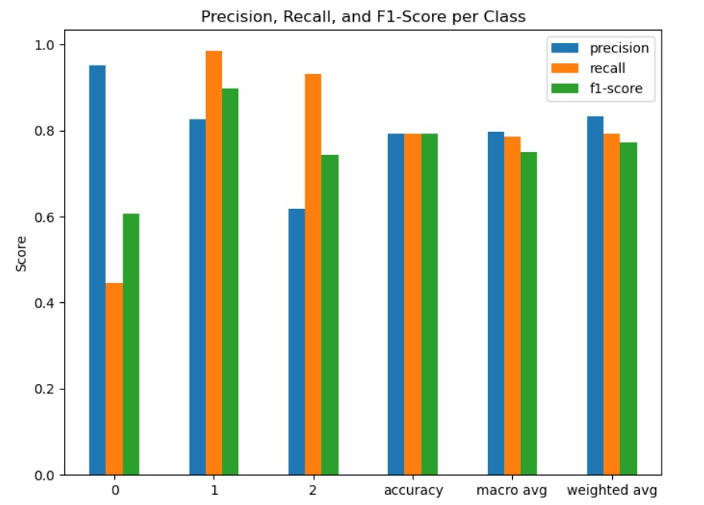

This figure summarizes the precision, recall, and F1-score for each class (rubric label) predicted by the final model:
Class Labels:
- 0: Task Response
- 1: Coherence and Cohesion
- 2: Lexical Resource
Key Observations:
- Class 0 (Task Response):
  - High precision (~0.9) but relatively low recall (~0.45).
  - Indicates the model is very accurate when it predicts Task Response, but it misses many actual Task Response sentences.
- Class 1 (Coherence and Cohesion):
  - Strong across all metrics with very high recall (~0.95) and decent precision (~0.83).
  - Suggests that the model reliably captures sentences related to coherence and flow.
- Class 2 (Lexical Resource):
  - Good performance, but slightly lower than Class 1.
  - Recall (~0.75) is slightly lower, meaning some Lexical Resource sentences are missed.
MODEL 1
Text -> Embeddings
MODEL2
Embeddings -> Fine - tund features
TORCH CLASSIFICATION
Final Classifier

5. FINAL RESULTS

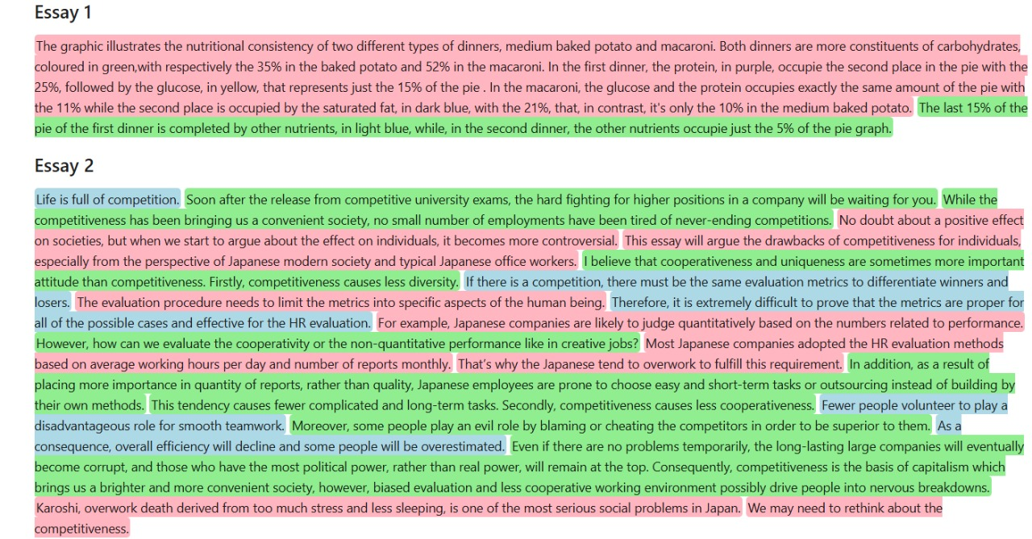
This figure shows the final output of the proposed system, where each sentence of an IELTS essay is classified and highlighted based on its contribution to specific IELTS rubrics.
Highlights:
- 🟥 Task Response (TR):
Sentences that directly respond to the essay question, make arguments, or state key points.
- 🟩 Coherence and Cohesion (CC):
Sentences that ensure logical progression of ideas, using linking words and connecting paragraphs smoothly.
- 🟦 Lexical Resource (LR):
Sentences that demonstrate a rich and precise use of vocabulary, including topic-specific terms and collocations.

6. Conclusion
In this project, we proposed and developed a transformer-based system for the automated rubric-based evaluation of IELTS essays. Addressing the challenges of manual grading — including time consumption, inconsistency, and subjectivity — the system aims to assist human evaluators by classifying sentences into three important IELTS rubric categories: Task Response, Coherence and Cohesion, and Lexical Resource.
We curated a dataset of IELTS Task 1 and Task 2 essays collected from various online educational platforms, ensuring that real-world grammatical and spelling errors were retained to closely simulate authentic student submissions. After preprocessing and segmenting essays into individual sentences, we extracted contextual embeddings using a frozen pre-trained transformer model (BERT-base-uncased). These embeddings were then fed into classical classifiers like Support Vector Machines and Logistic Regression for rubric-specific sentence prediction.
Among the two architectural approaches explored, using frozen transformer embeddings combined with a lightweight classical classifier proved to be the most effective and efficient, balancing strong performance with low computational cost and reduced risk of overfitting.
The final system outputs rubric-highlighted essays, providing graders with a structured and insightful overview of the essay's strengths and weaknesses according to IELTS standards.
By automating rubric-specific classification at the sentence level, this project offers a practical solution to accelerate the grading process, reduce grader fatigue, and enhance consistency across large volumes of IELTS essays. Furthermore, it lays a foundation for future work in automated feedback generation, full band score prediction, and personalized learning feedback systems for English language learners.

7. FUTURE WORK

Grammatical Range and Accuracy Classification
- Extend the model to automatically detect and classify Grammatical Range and Accuracy, which was excluded in this project due to its complexity.

Fine-Tuning Transformers End-to-End
- Explore end-to-end fine-tuning of transformer models with larger labeled datasets to improve classification accuracy, especially for subtle distinctions between rubrics.

Automated Feedback Generation
- Develop a feedback generation module that automatically suggests actionable improvements for each rubric.

